Russell Bjella

ASEN 6008 – Homework 4

2/22/17

1. Planar venus flyby
   1. Initial specific energy: -531.548249 km^2/s^2
   2. 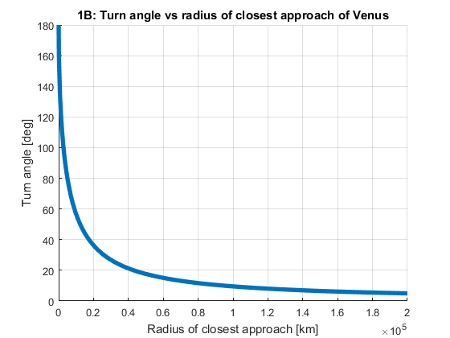Closest approach between 0 and 200,000 km
   3. 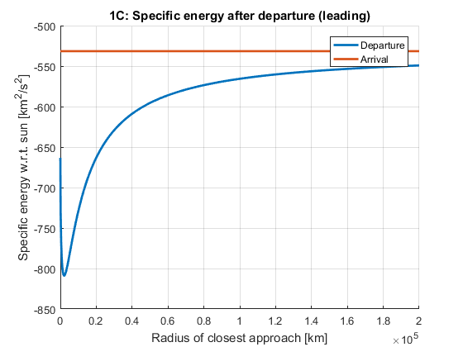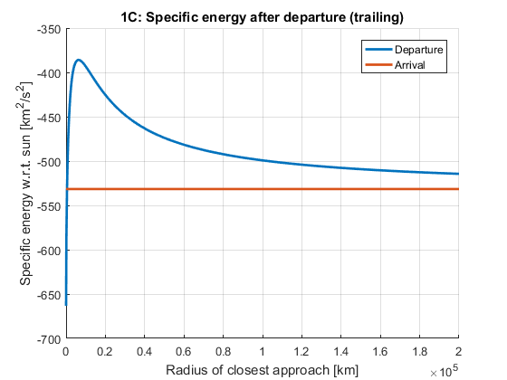Energy after the flyby
   4. For maximum energy change, the flyby should have as low a radius of closest approach as possible, accounting for the size and atmosphere of the planet.
2. Earth gravity assist – MATLAB output pasted

PROBLEM 2

Turn angle: 38.598242 deg

Radius of closest approach: 9975.867572 km

Magnitude of B vector: 14063.155543 km

Theta: 0.365159 deg

B_T: 13135.930533 km

B_R: 5021.919240 km

1. MATLAB output

PROBLEM 3

V_inf_in: [3.736241 -3.987503 -0.057270] km/s

V_inf_out: [2.416392 -5.734309 -0.003020] km/s

|V_inf_in|: 5.464701 |V_inf_out|: 6.222641

Radius of closest approach: 62415.255456 km

The magnitudes of the V_inf vectors do not match exactly because they are only equal if only considering the gravitation between the planet and the spacecraft. There are perturbing gravitational forces such as those from the sun, Earth, and Jupiter. The spacecraft’s energy increases with respect to the sun after the flyby.